**Before starting the game directories of the images need to be adjusted.**

1. Go to the Images class
2. Select the D:\ part on any one of the image URIs



1. Click Ctrl + H



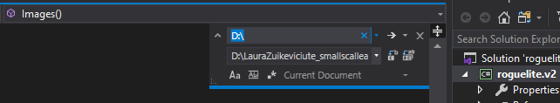

1. Then open File Explorer
2. Go to the folder where the game is extracted to

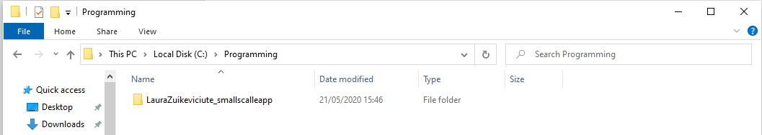

1. Without opening the game folder, you can copy the directory
2. Click on this this and copy it (Ctrl + C)



1. Then go back to Visual Studio and paste (Ctrl + V) the directory here

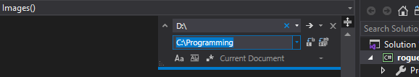

1. Then click Replace All or just Alt + A

**All the image directories should now be updated, you can now play the game, good luck!**